Pareto distribution

Def

Parameter



Support



PDF

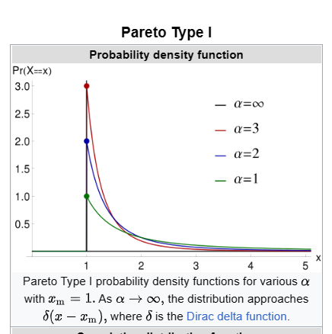



CDF

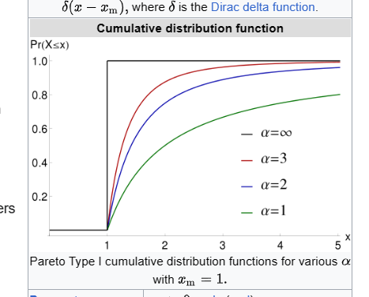



Expected Value



Variance

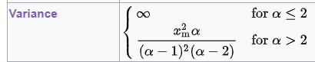

Median



Mode



Skewness



Ex. Kurtosis



Entropy



MGF



CF



Fisher’s info

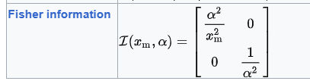

Ref

[Pareto distribution - Wikipedia](https://en.wikipedia.org/wiki/Pareto_distribution)